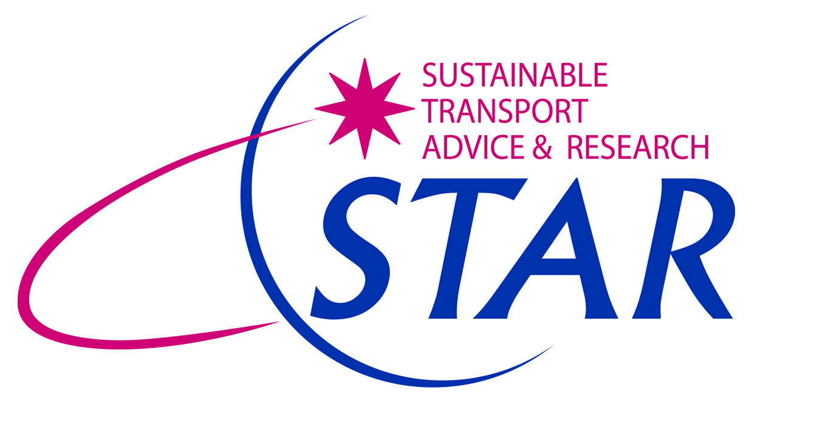

Community Transport for the 21st Century

STAR is a small, East Midlands based transport consultancy, specialising in passenger transport. We work closely with the Voluntary and Community Sector to assist them to grow and develop the transport services they offer.

We have considerable expertise in preparing successful transport funding bids. We can assist with bids for National Lottery awards, Local Sustainable Transport Fund (LSTF) monies from national government and drawing down funds from the EU. We are willing to enter into partnership with community transport operators and local authorities to secure shared funding for community transport operations.

We are experts in developing community transport solutions and assisting operators to become more socially enterprising:

- We recently completed two studies for Nottinghamshire County Council, in partnership with the local community transport operators, to assess the feasibility of new community minibuses for the Borough of Broxtowe and the District of Bassetlaw
- We conducted an independent review of County Council-funded Dial-a-Bus services in Derbyshire, in full consultation with the community transport operators
- We worked with Rutland County Council and the local Voluntary Action Centre to assess the feasibility and commercial viability of a new social enterprise to deliver minibus services for Rutland.

We are full of ideas! Contact STAR today and let us help you grow your community transport business and secure new sources of sustainable funding.

Clare Waldron and Norman James
Directors
STAR Independent Consultants Limited
M: 07867 871405 or 07917 692443
clare@startransport.co.uk
norman@startransport.co.uk
www.startransport.co.uk

